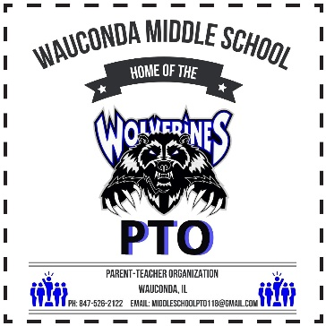
2023-2024 PTO Volunteer Form

The WMS PTO needs you, and there are numerous opportunities to get involved. Even for an hour or two, your participation can make a difference. The WMS PTO have planned a full year of activities and events.
To be successful we need parents like you to volunteer!
Please take a moment to complete the form below indicating where you will be able to help. Please return the completed form to the school office or send a photo of the form via email.

Thank you for your support! Email: middleschoolpto118@gmail.com
===========================================================================

Name: __________________________________________ Phone: ________________________

Child’s name and grade(s): _________________________________________________________

Cell#: _________________________ Email: _________________________________________

Volunteering Opportunities:

_____ Popcorn Sales During Lunch Hours (Fridays…see WMS PTO Calendar for dates)

_____ Conference Dinner for Staff (Hours available or Donate Food Item)

_____ Holiday Shop (December)

_____ Holiday Staff Appreciation (December - Donate food item)

_____Teacher Appreciation Day (– Donate Food Item)

_____ Color Run 2023 /24 (details TBA)

_____ Sporting Events
2023-2024 WMS PTO Board Members

Consuelo Rivera | President | Lisa Kuklewski | Vice- President
Stacey Haas | Treasurer | Zabrina Zajac | Secretary

